Experiment 1
Basic File and User Management Commands
Aim
To execute and understand the usage of rm, users, and tree commands in Kali Linux.
Procedure
1. Open Kali Linux Terminal.
2. Create a sample file.
3. Execute the rm command.
4. Execute the users command.
5. Execute the tree command.

Output
- rm command:
The rm command is used to remove files and directories from the Linux file system.

Syntax:
rm filename

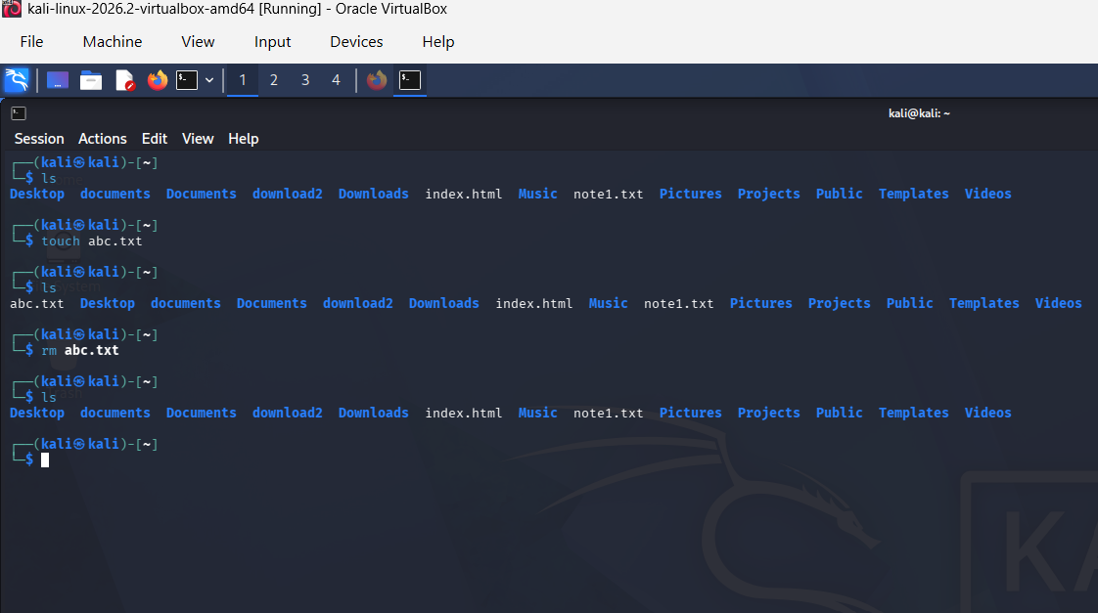

- Users command
Displays the usernames of users currently logged into the system.

Syntax:
users
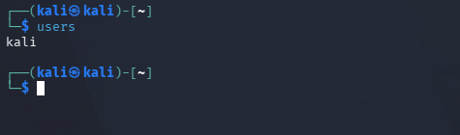

- Tree Command
Displays directories and files in a tree-like structure.

Syntax:
Tree

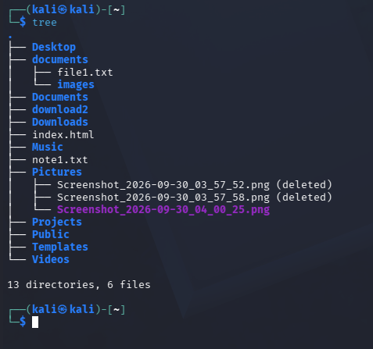

Result
Successfully executed rm, users, and tree commands in Kali Linux.

